Task 1-1017-Vuppala Likitha

**1.List of microprocessors**

**a.Intel**

**b.Amd**

**c.Apple chips**

Microprocessor:-to execute the task.

**a.Intel:-**

we have generations like 7,8,9, 10,11,12,13

7 generation core,8 generation core,9 generation core,10 generation core,11 generation core,12 generation core,13 generation core

Recently we are using 10, 11 generations.

**10 generation core:-** we have core 4, core 6,core 8,core 10

**11 generation core:-**we have corei5,corei7,corei9

**12 generation core:-**we have corei3,corei5,corei7,corei9

**b.AMD:- Laptop processors**

### [AMD Ryzen™ PRO Mobile Processors for Business](https://www.amd.com/en/products/ryzen-pro-processors-laptop)

Multi-core performance and battery life + manageability and additional security features.

### [AMD Ryzen™ Mobile Processors for Business](https://www.amd.com/en/processors/ryzen-processors-laptop-business)

Responsive, multi-core performance with superb efficiency and battery life.

### [AMD Ryzen™ Mobile Processors](https://www.amd.com/en/processors/ryzen-processors-laptop)

The most cores available, with the highest performance you can get in a mobile processor.1

### [AMD Athlon™ Mobile Processors](https://www.amd.com/en/processors/athlon-mobile)

Real performance and modern features for mainstream laptops.

### [AMD Powered Laptops for Students and Teachers](https://www.amd.com/en/processors/windows-for-education)

AMD processors with Radeon™ Graphics deliver fast web browsing performance and smooth video streaming to support online learning environments.

**c.Apple chips**:- we have series like Aseries,Mseries, Sseries,Tseries,Wseries,Hseries,Useries

**A series:-**

* [**Apple A4**](https://apple.fandom.com/wiki/Apple_A4) — (2010) introduced in the [original iPad](https://apple.fandom.com/wiki/IPad_(1st_generation)) and also used in the [iPhone 4](https://apple.fandom.com/wiki/IPhone_4), [iPod touch (4th generation)](https://apple.fandom.com/wiki/IPod_touch_(4th_generation)), and [Apple TV (2nd generation)](https://apple.fandom.com/wiki/Apple_TV_(2nd_generation)).
* **Apple A5** — (2011) introduced in the [iPad 2](https://apple.fandom.com/wiki/IPad_2) and used in the [iPhone 4S](https://apple.fandom.com/wiki/IPhone_4S), [iPod touch (5th generation)](https://apple.fandom.com/wiki/IPod_touch_(5th_generation)) and [1st generation iPad mini](https://apple.fandom.com/wiki/IPad_mini).
* [**Apple A5X**](https://apple.fandom.com/wiki/Apple_A5X) — (2012) introduced in the [iPad (3rd generation)](https://apple.fandom.com/wiki/IPad_(3rd_generation)).
* **Apple A6** — (2012) introduced in the [iPhone 5](https://apple.fandom.com/wiki/IPhone_5) and later used in the [iPhone 5C](https://apple.fandom.com/wiki/IPhone_5C); contained a custom CPU designed internally at Apple (called "Swift") instead of one licensed from [ARM](https://apple.fandom.com/wiki/ARM).[[10]](https://apple.fandom.com/wiki/List_of_Apple_processors#cite_note-A6NamedSwift-10)
* [**Apple A6X**](https://apple.fandom.com/wiki/Apple_A6X) — (2012) introduced in the [iPad (4th generation)](https://apple.fandom.com/wiki/IPad_(4th_generation)).
* **Apple A7** — (2013) introduced in the [iPhone 5S](https://apple.fandom.com/wiki/IPhone_5S), the company's first [64-bit](https://apple.fandom.com/wiki/64-bit) mobile processor. Also used in the 2nd and 3rd generation [iPad minis](https://apple.fandom.com/wiki/IPad_mini) and 1st generation [iPad Air](https://apple.fandom.com/wiki/IPad_Air).[[1]](https://apple.fandom.com/wiki/List_of_Apple_processors#cite_note-bloomberg-most-important-apple-executive-1)
* **Apple A8** — (2014) introduced in the [iPhone 6](https://apple.fandom.com/wiki/IPhone_6) and [6 Plus](https://apple.fandom.com/wiki/IPhone_6_Plus); also used by the [iPad mini 4](https://apple.fandom.com/wiki/IPad_mini_4), [6th generation iPod touch](https://apple.fandom.com/wiki/IPod_touch_(6th_generation)), and the [1st-generation HomePod](https://apple.fandom.com/wiki/HomePod_(1st_generation)).
* **Apple A8X** — (2014) introduced in the [iPad Air 2](https://apple.fandom.com/wiki/IPad_Air_2).
* **Apple A9** — (2015) introduced in the [iPhone 6S](https://apple.fandom.com/wiki/IPhone_6S) and [6S Plus](https://apple.fandom.com/wiki/IPhone_6S_Plus), and later used in the [1st-generation iPhone SE](https://apple.fandom.com/wiki/IPhone_SE_(1st_generation)) and the [5th-generation iPad](https://apple.fandom.com/wiki/IPad_(5th_generation)).
* **Apple A9X** — (2015) introduced in the [1st-generation iPad Pro](https://apple.fandom.com/wiki/IPad_Pro_(1st_generation)), the company's first "desktop class" processor for mobile devices.[[1]](https://apple.fandom.com/wiki/List_of_Apple_processors#cite_note-bloomberg-most-important-apple-executive-1)
* [**Apple A10**](https://apple.fandom.com/wiki/Apple_A10)**Fusion** — (2016) introduced in the [iPhone 7](https://apple.fandom.com/wiki/IPhone_7) and [7 Plus](https://apple.fandom.com/wiki/IPhone_7_Plus), and later used in the [6th](https://apple.fandom.com/wiki/IPad_(6th_generation)) and [7th-generation iPad](https://apple.fandom.com/wiki/IPad_(7th_generation)). This was the first processor produced for Apple solely by [TSMC](https://apple.fandom.com/wiki/TSMC).[[9]](https://apple.fandom.com/wiki/List_of_Apple_processors#cite_note-9to5mac-appledropsamsung-9)
* **Apple A10X Fusion** — (2017) introduced in the [2nd-generation iPad Pro](https://apple.fandom.com/wiki/IPad_Pro_(2nd_generation)), and also used in the [1st-generation Apple TV 4K](https://apple.fandom.com/wiki/Apple_TV_4K_(1st_generation)).
* **Apple A11 Bionic** — (2017) introduced in the [iPhone 8](https://apple.fandom.com/wiki/IPhone_8), [8 Plus](https://apple.fandom.com/wiki/IPhone_8_Plus), and [iPhone X](https://apple.fandom.com/wiki/IPhone_X). First implementation of [Neural Engine](https://apple.fandom.com/wiki/Neural_Engine) [machine learning](https://apple.fandom.com/wiki/Machine_learning).
* **Apple A12 Bionic** — (2018) introduced in the [iPhone XR](https://apple.fandom.com/wiki/IPhone_XR), [XS](https://apple.fandom.com/wiki/IPhone_XS), and [XS Max](https://apple.fandom.com/wiki/IPhone_XS_Max), and also used in the [3rd-generation iPad Air](https://apple.fandom.com/wiki/IPad_Air_(3rd_generation)), [5th-generation iPad mini](https://apple.fandom.com/wiki/IPad_mini_(5th_generation)) and the [2nd-generation Apple TV 4K](https://apple.fandom.com/wiki/Apple_TV_4K_(2nd_generation)), and later used in the [8th-generation iPad](https://apple.fandom.com/wiki/IPad_(8th_generation)).
* [**Apple A12X**](https://apple.fandom.com/wiki/Apple_A12X)**Bionic** — (2018) introduced in the [3rd-generation iPad Pro](https://apple.fandom.com/wiki/IPad_Pro_(3rd_generation)).
* [**Apple A12Z**](https://apple.fandom.com/wiki/Apple_A12Z)**Bionic** — (2020) introduced in the [4th-generation iPad Pro](https://apple.fandom.com/wiki/IPad_Pro_(4th_generation)), and used in the 2020 [Mac mini](https://apple.fandom.com/wiki/Mac_mini)-based [Developer Transition Kit](https://apple.fandom.com/wiki/Developer_Transition_Kit_(2020)).
* **Apple A13 Bionic** — (2019) introduced in the [iPhone 11](https://apple.fandom.com/wiki/IPhone_11), [11 Pro](https://apple.fandom.com/wiki/IPhone_11_Pro), [11 Pro Max](https://apple.fandom.com/wiki/IPhone_11_Pro_Max); also used in the [2nd-generation iPhone SE](https://apple.fandom.com/wiki/IPhone_SE_(2nd_generation)), [9th-generation iPad](https://apple.fandom.com/wiki/IPad_(9th_generation)), and [Studio Display](https://apple.fandom.com/wiki/Studio_Display).
* [**Apple A14**](https://apple.fandom.com/wiki/Apple_A14)**Bionic** — (2020) introduced in the [4th-generation iPad Air](https://apple.fandom.com/wiki/IPad_Air_(4th_generation)); also used in the [iPhone 12](https://apple.fandom.com/wiki/IPhone_12) series and the [10th-generation iPad](https://apple.fandom.com/wiki/IPad_(10th_generation)).[[11]](https://apple.fandom.com/wiki/List_of_Apple_processors#cite_note-youtube-apple-event915-11)[[12]](https://apple.fandom.com/wiki/List_of_Apple_processors#cite_note-researchsnipers-apple-a14-3.1ghz-12)[[13]](https://apple.fandom.com/wiki/List_of_Apple_processors#cite_note-apple-redesigned-ipad-13)
* [**Apple A15**](https://apple.fandom.com/wiki/Apple_A15)**Bionic** — (2021) introduced in the [iPhone 13](https://apple.fandom.com/wiki/IPhone_13) series and the [6th-generation iPad mini](https://apple.fandom.com/wiki/IPad_mini_(6th_generation));[[14]](https://apple.fandom.com/wiki/List_of_Apple_processors#cite_note-yt-apple-event-2021-09-14) also adopted by the [3rd-generation iPhone SE](https://apple.fandom.com/wiki/IPhone_SE_(3rd_generation)) in March [2022](https://apple.fandom.com/wiki/2022).[[15]](https://apple.fandom.com/wiki/List_of_Apple_processors#cite_note-yt-peek-performance-15)
* [**Apple A16**](https://apple.fandom.com/wiki/Apple_A16)**Bionic** — (2022) introduced in the [iPhone 14 Pro](https://apple.fandom.com/wiki/IPhone_14_Pro) and [14 Pro Max](https://apple.fandom.com/wiki/IPhone_14_Pro_Max).[[16]](https://apple.fandom.com/wiki/List_of_Apple_processors#cite_note-yt-apple-event-2022-far-out-16)

**M series:-**

* [**Apple M1**](https://apple.fandom.com/wiki/Apple_M1) — introduced in November [2020](https://apple.fandom.com/wiki/2020) with support for up to 16 [GB](https://apple.fandom.com/wiki/GB) [RAM](https://apple.fandom.com/wiki/RAM) for the first Apple Silicon-based Macs, the [MacBook Air](https://apple.fandom.com/wiki/MacBook_Air), 13-inch [MacBook Pro](https://apple.fandom.com/wiki/MacBook_Pro), and [Mac mini](https://apple.fandom.com/wiki/Mac_mini);[[18]](https://apple.fandom.com/wiki/List_of_Apple_processors#cite_note-apple-unleashes-m1-18) also adopted by the 24-inch [iMac](https://apple.fandom.com/wiki/IMac) and [5th-generation iPad Pro](https://apple.fandom.com/wiki/IPad_Pro_(5th_generation)) in April [2021](https://apple.fandom.com/wiki/2021);[[19]](https://apple.fandom.com/wiki/List_of_Apple_processors#cite_note-yt-apple-event-2021-04-19) as well as the [5th-generation iPad Air](https://apple.fandom.com/wiki/IPad_Air_(5th_generation)) in March [2022](https://apple.fandom.com/wiki/2022).[[15]](https://apple.fandom.com/wiki/List_of_Apple_processors#cite_note-yt-peek-performance-15)
* [**Apple M1 Pro**](https://apple.fandom.com/wiki/Apple_M1_Pro) — introduced in October [2021](https://apple.fandom.com/wiki/2021) with support for up to 32 [GB](https://apple.fandom.com/wiki/GB) [RAM](https://apple.fandom.com/wiki/RAM) for the 14 and 16-inch [MacBook Pros](https://apple.fandom.com/wiki/MacBook_Pro).[[20]](https://apple.fandom.com/wiki/List_of_Apple_processors#cite_note-apple-introducing-m1pro-m1max-20)
* [**Apple M1 Max**](https://apple.fandom.com/wiki/Apple_M1_Max) — introduced in October [2021](https://apple.fandom.com/wiki/2021) with support for up to 64 [GB](https://apple.fandom.com/wiki/GB) [RAM](https://apple.fandom.com/wiki/RAM) in the 14 and 16-inch [MacBook Pros](https://apple.fandom.com/wiki/MacBook_Pro);[[20]](https://apple.fandom.com/wiki/List_of_Apple_processors#cite_note-apple-introducing-m1pro-m1max-20) also adopted by the base model [Mac Studio](https://apple.fandom.com/wiki/Mac_Studio) in March [2022](https://apple.fandom.com/wiki/2022).[[15]](https://apple.fandom.com/wiki/List_of_Apple_processors#cite_note-yt-peek-performance-15)
* [**Apple M1 Ultra**](https://apple.fandom.com/wiki/Apple_M1_Ultra) — introduced in March [2022](https://apple.fandom.com/wiki/2022) with support for up to 128 [GB](https://apple.fandom.com/wiki/GB) [RAM](https://apple.fandom.com/wiki/RAM) in the [Mac Studio](https://apple.fandom.com/wiki/Mac_Studio).[[15]](https://apple.fandom.com/wiki/List_of_Apple_processors#cite_note-yt-peek-performance-15)
* [**Apple M2**](https://apple.fandom.com/wiki/Apple_M2) — introduced in June [2022](https://apple.fandom.com/wiki/2022) to support the new [MacBook Air](https://apple.fandom.com/wiki/MacBook_Air) and the 13-inch [MacBook Pro](https://apple.fandom.com/wiki/MacBook_Pro);[[21]](https://apple.fandom.com/wiki/List_of_Apple_processors#cite_note-yt-apple-event-wwdc2022-06-06-21) also adopted by the [6th-generation iPad Pro](https://apple.fandom.com/wiki/IPad_Pro_(6th_generation)) in October 2022 and the updated base model [Mac mini](https://apple.fandom.com/wiki/Mac_mini) in January [2023](https://apple.fandom.com/wiki/2023).[[22]](https://apple.fandom.com/wiki/List_of_Apple_processors#cite_note-apple-next-ipadpro-m2-22)[[23]](https://apple.fandom.com/wiki/List_of_Apple_processors#cite_note-23)
* [**Apple M2 Pro**](https://apple.fandom.com/wiki/Apple_M2_Pro) — introduced in January [2023](https://apple.fandom.com/wiki/2023) with support for the updated [Mac mini](https://apple.fandom.com/wiki/Mac_mini), and 14 and 16-inch [MacBook Pros](https://apple.fandom.com/wiki/MacBook_Pro).[[24]](https://apple.fandom.com/wiki/List_of_Apple_processors#cite_note-apple-unveils-m2pro-m2max-24)
* [**Apple M2 Max**](https://apple.fandom.com/wiki/Apple_M2_Max) — introduced in January [2023](https://apple.fandom.com/wiki/2023) with support for up to 96 [GB](https://apple.fandom.com/wiki/GB) [RAM](https://apple.fandom.com/wiki/RAM) in the updated 14 and 16-inch [MacBook Pros](https://apple.fandom.com/wiki/MacBook_Pro).[[24]](https://apple.fandom.com/wiki/List_of_Apple_processors#cite_note-apple-unveils-m2pro-m2max-24)

M series (motion coprocessors)

* [**Apple M7**](https://apple.fandom.com/wiki/Apple_M7) — introduced with the Apple A7 in the [iPhone 5S](https://apple.fandom.com/wiki/IPhone_5S) in September [2013](https://apple.fandom.com/wiki/2013).
* [**Apple M8**](https://apple.fandom.com/wiki/Apple_M8) — introduced with the Apple A8 in the [iPhone 6](https://apple.fandom.com/wiki/IPhone_6) and [6 Plus](https://apple.fandom.com/wiki/IPhone_6_Plus) in September [2014](https://apple.fandom.com/wiki/2014)

**S series:-**

**Apple S1** — introduced in the [original Apple Watch](https://apple.fandom.com/wiki/Apple_Watch_(original)).

**Apple S1P** — introduced in the [Apple Watch Series 1](https://apple.fandom.com/wiki/Apple_Watch_Series_1).

**Apple S2** — introduced in the [Apple Watch Series 2](https://apple.fandom.com/wiki/Apple_Watch_Series_2).

**Apple S3** — introduced in the [Apple Watch Series 3](https://apple.fandom.com/wiki/Apple_Watch_Series_3).

**Apple S4** — introduced in the [Apple Watch Series 4](https://apple.fandom.com/wiki/Apple_Watch_Series_4).

**Apple S5** — introduced in the [Apple Watch Series 5](https://apple.fandom.com/wiki/Apple_Watch_Series_5); also used in the [1st-generation Apple Watch SE](https://apple.fandom.com/wiki/Apple_Watch_SE_(1st_generation)) and [HomePod mini](https://apple.fandom.com/wiki/HomePod_mini" \o "HomePod mini).

**Apple S6** — introduced in the [Apple Watch Series 6](https://apple.fandom.com/wiki/Apple_Watch_Series_6).

**Apple S7** — introduced in the [Apple Watch Series 7](https://apple.fandom.com/wiki/Apple_Watch_Series_7); also used in the [2nd-generation HomePod](https://apple.fandom.com/wiki/HomePod_(2nd_generation)).

**Apple S8** — introduced in the [Apple Watch Series 8](https://apple.fandom.com/wiki/Apple_Watch_Series_8); also used in the [2nd-generation Apple Watch SE](https://apple.fandom.com/wiki/Apple_Watch_SE_(2nd_generation)) and [Apple Watch Ultra](https://apple.fandom.com/wiki/Apple_Watch_Ultra).

## **T series**

* **Apple T1** — manages the [system management controller](https://apple.fandom.com/wiki/System_management_controller) (SMC) in the 2016 and 2017 [MacBook Pros](https://apple.fandom.com/wiki/MacBook_Pro)
* **Apple T2** — introduced in the [iMac Pro](https://apple.fandom.com/wiki/IMac_Pro) and future Intel Macs. Based on the [Apple A10](https://apple.fandom.com/wiki/Apple_A10).

## **W series**

* [**Apple W1**](https://apple.fandom.com/wiki/Apple_W1) — manages [Bluetooth](https://apple.fandom.com/wiki/Bluetooth) and battery usage in the 1st-generation [AirPods](https://apple.fandom.com/wiki/AirPods" \o "AirPods).
* **Apple W2** — integrated into the Apple S3 used in the [Apple Watch Series 3](https://apple.fandom.com/wiki/Apple_Watch_Series_3).
* **Apple W3** — integrated into the Apple S4, S5, and S6 used in the [Apple Watch Series 4](https://apple.fandom.com/wiki/Apple_Watch_Series_4), [5](https://apple.fandom.com/wiki/Apple_Watch_Series_5), [6](https://apple.fandom.com/wiki/Apple_Watch_Series_6), and [SE](https://apple.fandom.com/wiki/Apple_Watch_SE).

### H series

* [**Apple H1**](https://apple.fandom.com/wiki/Apple_H1) — introduced in the [2nd-generation AirPods](https://apple.fandom.com/wiki/AirPods_(2nd_generation)) for increased efficiency over the W1.
* **Apple H2** — introduced in the [2nd-generation AirPods Pro](https://apple.fandom.com/wiki/AirPods_Pro_(2nd_generation)).

## **U series**

* **Apple U1** — uses [ultra-wideband](http://en.wikipedia.org/wiki/ultra-wideband) technology to control spatial awareness in the [iPhone 11](https://apple.fandom.com/wiki/IPhone_11) series, [iPhone 12](https://apple.fandom.com/wiki/IPhone_12) series, [iPhone 13](https://apple.fandom.com/wiki/IPhone_13) series, [HomePod mini](https://apple.fandom.com/wiki/HomePod_mini" \o "HomePod mini), [Apple Watch Series 6](https://apple.fandom.com/wiki/Apple_Watch_Series_6), and [AirTags](https://apple.fandom.com/wiki/AirTag" \o "AirTag).

**2**.Difference between HDD And SSD?

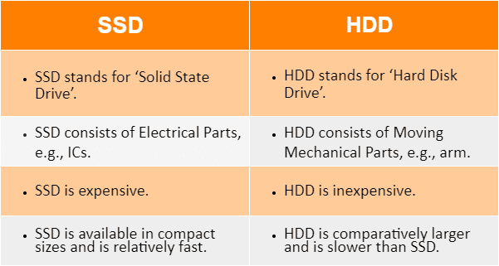

3.choose a best laptop for:-

a.web Developer:-50,000

**Lenovo IdeaPad 3 Laptop**

Because [web design and development](https://www.knowledgehut.com/blog/web-development/web-design-vs-web-development) are demanding jobs, you must possess a best laptop for web development 2023 that can function smoothly.

The design of this model is greatly improved over previous incarnations. It has a sleek, attractive design with a 4-sided narrow bezel that allows you to view more of the FHD screen. It also helps to reduce clutter while utilizing other goods.

The cooling system is the most remarkable aspect of this smart device. It is a laptop for front end developer and uses innovative methods to efficiently cool the pc.

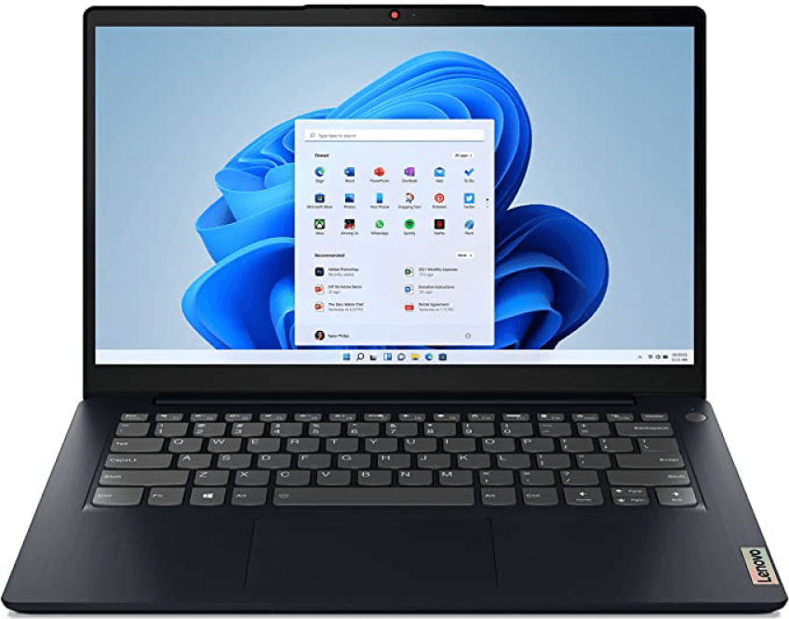

Source: Amazon.com

**Specifications/Summary**

* Brand: Lenovo
* Color: Abyss Blue
* Hard Disk Size: 256 GB
* CPU Model: AMD Ryzen 5 5500U
* Series: 2021
* Screen Size: 14 Inches
* Ram Memory Installed Size: 8 GB
* Operating System: Windows 11
* Card Description: Integrated
* Graphics Coprocessor: AMD Radeo

**Top 3 Features**

* AMD Ryzen 5 5500U mobile processor, 8GB DDR4 RAM, 256GB SSD storage, and AMD Radeon 7 Graphics deliver outstanding performance.
* The IdeaPad 3 14-inch laptop has 4-side thin bezels that allow you to view more of the FHD (1920 x 1080) display for wider field of view angles and less clutter
* As well as intelligent thermals that are quieter and cooler, and you can fine tune performance with Q-control, which has three modes to match your performance needs.

**Pros:**

* Smooth functioning.
* Ergonomic design.
* Fast internet connection.
* Plenty of storage capacity.
* Cutting-edge cooling system.

**Cons:**

* Not appropriate for high-intensity gaming

**Rating:** 4.6 out of 5 on Amazon

**Price:** Rs. 40857

b.Graphics Designer:-75,000

[**Dell XPS 17 (2021)**](https://www.creativebloq.com/reviews/dell-xps-17)

The best big-screen laptop for graphic design

#### SPECIFICATIONS

**CPU:**Up to 11th Generation Intel Core i9-11980HK

**Graphics:**Up to NVIDIA GeForce RTX 3060 6GB GDDR6

**RAM:**Up to 64GB DDR4-3200MHz

**Screen:**17.0" FHD+ (1920 x 1200) InfinityEdge Non-Touch Anti-Glare 500-Nit – 17.0" UHD+ (3840 x 2400) InfinityEdge Touch Anti-Reflective 500-Nit

**Storage:**Up to 4TB M.2 PCIe NVMe

**TODAY'S BEST DEALS**

#### REASONS TO BUY

**+**Thin for a 17-inch laptop

**+**Excellent display with HDR

#### REASONS TO AVOID

**-**Unimpressive battery life

Having a gorgeous, large screen with a high resolution can be a great help for graphic designers, and this means the Dell XPS 17 is a laptop worth considering. It packs a fantastic 17-inch UHD+ screen with HDR, which makes your work look its very best. That larger screen also means working on this laptop feels comfortable, even for long periods of time.

The Dell XPS 17 also proves a large-screen laptop doesn't have to be big and bulky. This is an impressively thin and light laptop, with the same attractive design found in the smaller Dell XPS 13 and XPS 15 laptops. It also comes with some powerful components as well, including 11th generation Intel Core processors, up to 64GB RAM and an Nvidia RTX GeForce 3060 graphics card. We found this to be more than enough power for even the most intensive graphic design workloads when we tested it out – see our [Dell XPS 17 9710 review](https://www.creativebloq.com/reviews/dell-xps-17) for more details.

4. install VMware workstation17

## **Let us start Setup and Installation :**

**1.** Installing VMware Workstation from given below link. There are two options for downloading one is Windows and other for Linux. My Base Operating System is Windows8, So I choose for VMware for Windows. If Your Base OS is Linux go and choose VMware for Linux Link.

[**https://www.vmware.com/in/products/workstation-pro/workstation-pro-evaluation.html**](https://www.vmware.com/in/products/workstation-pro/workstation-pro-evaluation.html)

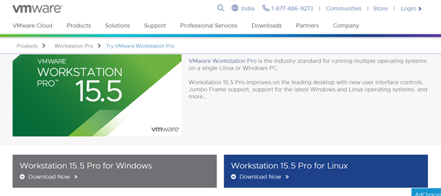

Image Credit :<https://medium.com/@ankitgupta_974>

**2**.Check your VMware Properties.

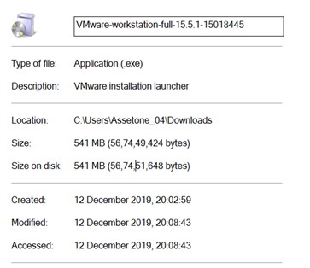

Image Credit :<https://medium.com/@ankitgupta_974>

**3.**Go to Download Folder.

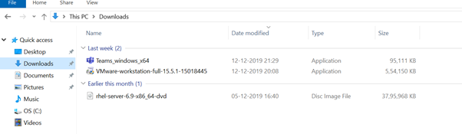

Image Credit :<https://medium.com/@ankitgupta_974>

**4.** Click the VMware downloaded File and Install it.

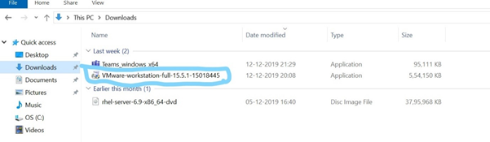

Image Credit :<https://medium.com/@ankitgupta_974>

**5.**Click on VMware Software and click and choose “**Pin to Taskbar”.**

**6.**Click on VMware Software and Click on Next to the Installation wizard.

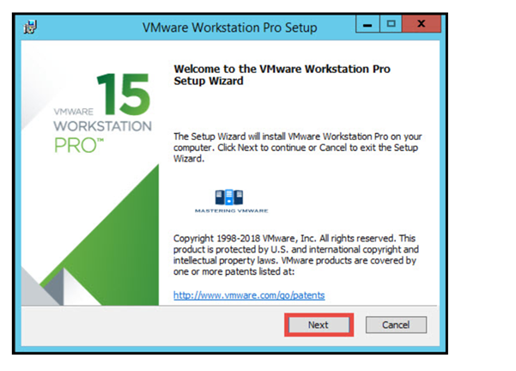

Image Credit :<https://medium.com/@ankitgupta_974>

**7.**Read and Accept the VMware End User license agreement.

Click Next to Continue.

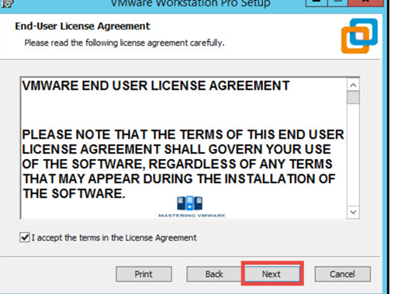

Image Credit :<https://medium.com/@ankitgupta_974>

**8.**Specify the Installation directory. You can also enable Enhance keyboard driver here.

Click Next to continue.

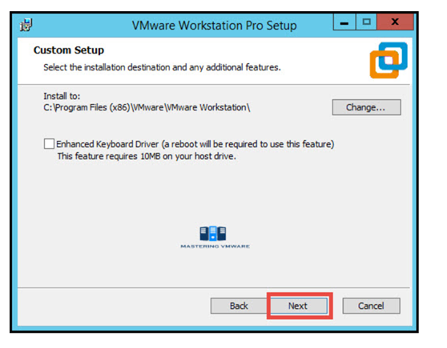

Image Credit :<https://medium.com/@ankitgupta_974>

**9.**You can enable product startup and join the VMware Customer experience Improvement program here.

Click Next to Continue.

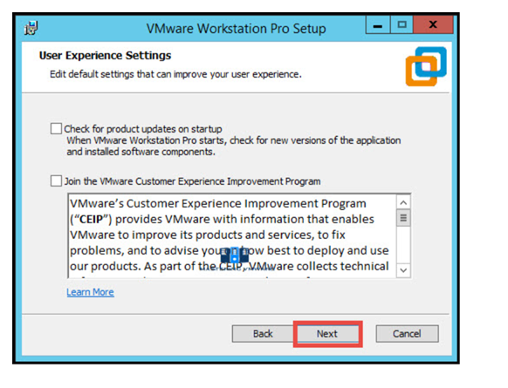

Image Credit :<https://medium.com/@ankitgupta_974>

**10.** Select the shortcuts you want to create for easy access to VMware Workstation.

Click Next to Continue.

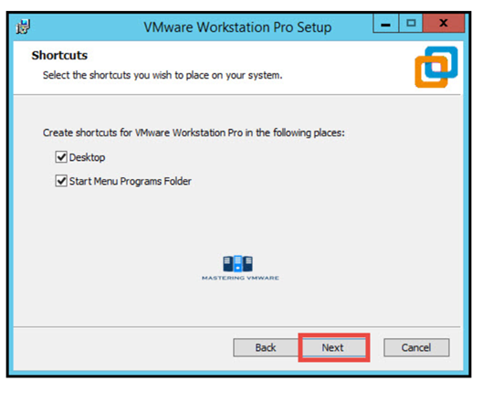

Image Credit :<https://medium.com/@ankitgupta_974>

**11.**Click Install button to start the installation.

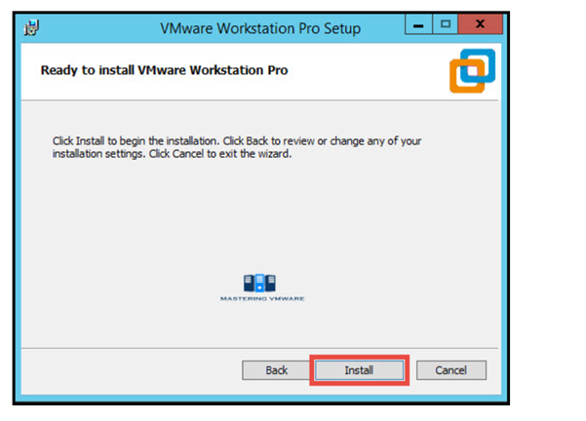

Image Credit :<https://medium.com/@ankitgupta_974>

**12.**Installation will take just few seconds to complete.

If you have license-key then click on License to enter the license or you can also click Finish to exit the Installer.

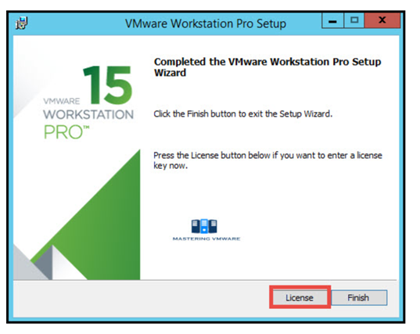

Image Credit :<https://medium.com/@ankitgupta_974>

**13.** Provide the License Key for VMware Workstation Pro.

Press Enter to continue.

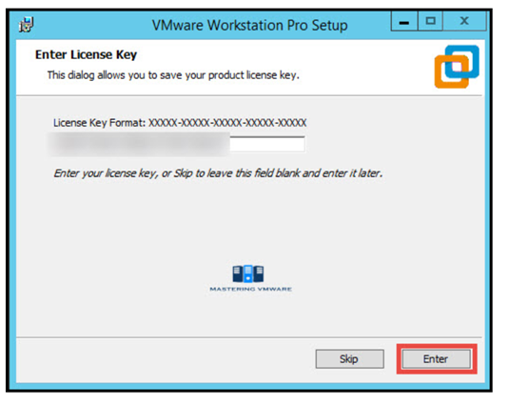

Image Credit :<https://medium.com/@ankitgupta_974>

(Suggestion : If you have Don’t License key search for internet or ask for who have already installed in their system. They surely have License Key.)

**14.**Click Finish to exit the wizard.

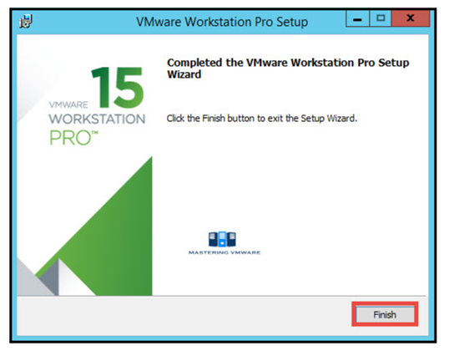

Image Credit :<https://medium.com/@ankitgupta_974>

**15.** That’s it we have successfully installed VMware Workstation Pro.

Now you can start the VMware Workstation Pro by clicking on the shortcut on Desktop.

Below is the Home screen of the VMware Workstation pro which you will see every time when you start Workstation.

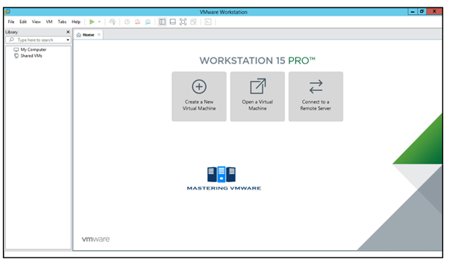

Image Credit :<https://medium.com/@ankitgupta_974>

**VMware successfully setup and installed**.

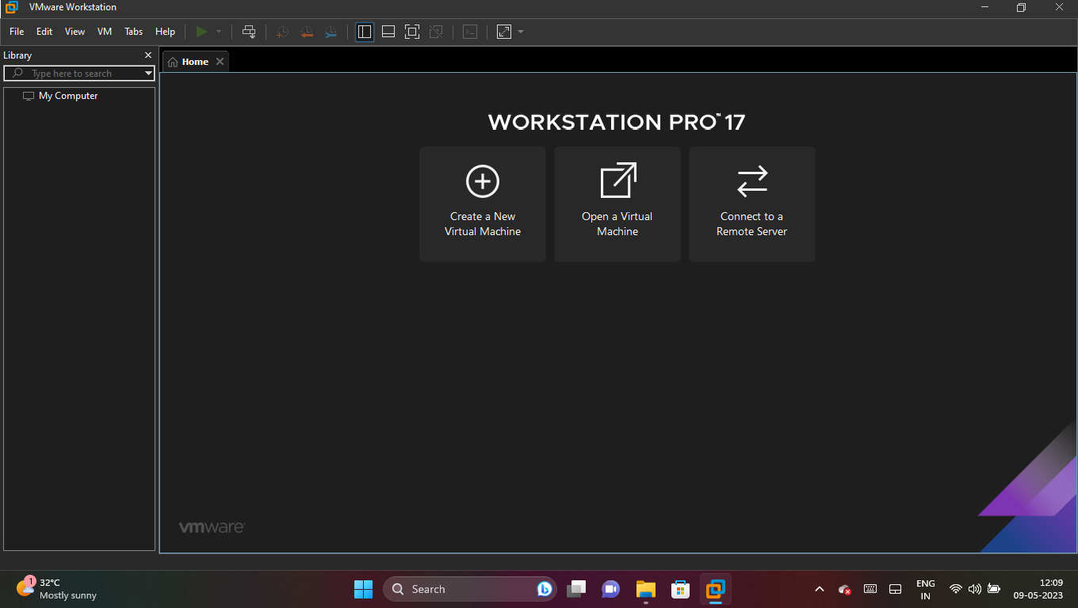

5.download and install Parrot Security Os

# How to install ParrotOS

This guide will help you install ParrotOS (latest version) on your computer step-by-step through the default official installer: Calamares.

This guide applies to both the [Security](https://parrotsec.org/download/?version=security) and [Home](https://parrotsec.org/download/?version=home) Edition.

Any problems or missing details, please report it to the official [Parrot forum](https://community.parrotsec.org/).

Insert your installation media into your computer and through your BIOS settings start Parrot. A screen will appear with several options, including some more advanced.

Select **Try/Install** and press Enter.

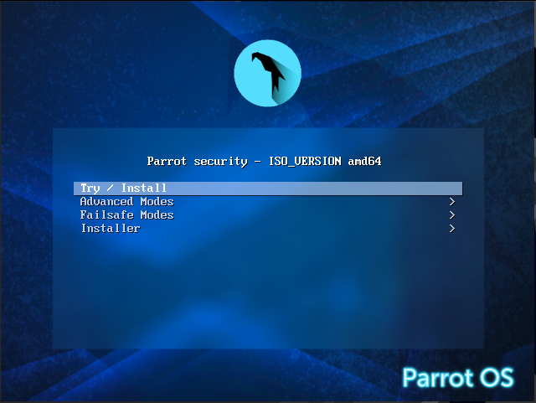

Wait for the OS to load (few seconds).

## Welcome in Parrot Live[​](https://parrotsec.org/docs/installation/#welcome-in-parrot-live)

Here you can test the OS in its entirety, then you can proceed with the installation.

Click on **Install Parrot**:

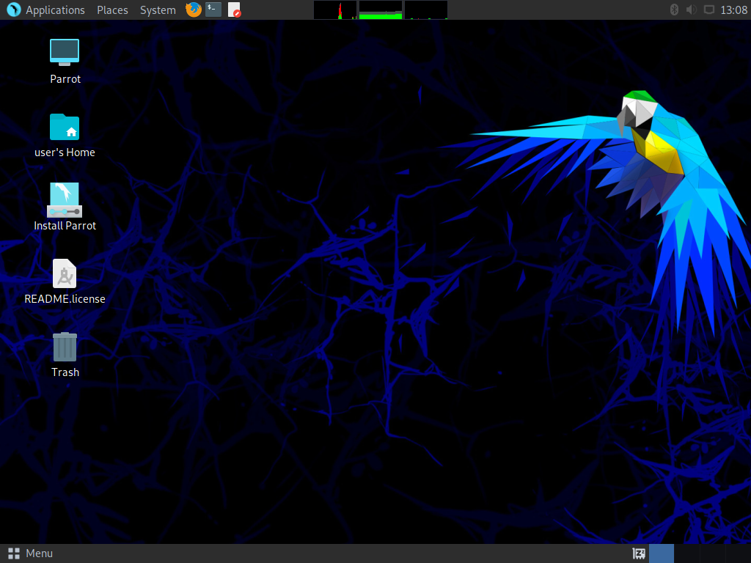

and the installer, Calamares, will start.

## Let's start![​](https://parrotsec.org/docs/installation/#lets-start)

The next step is selecting the system's language. Choose your language and click on Next.

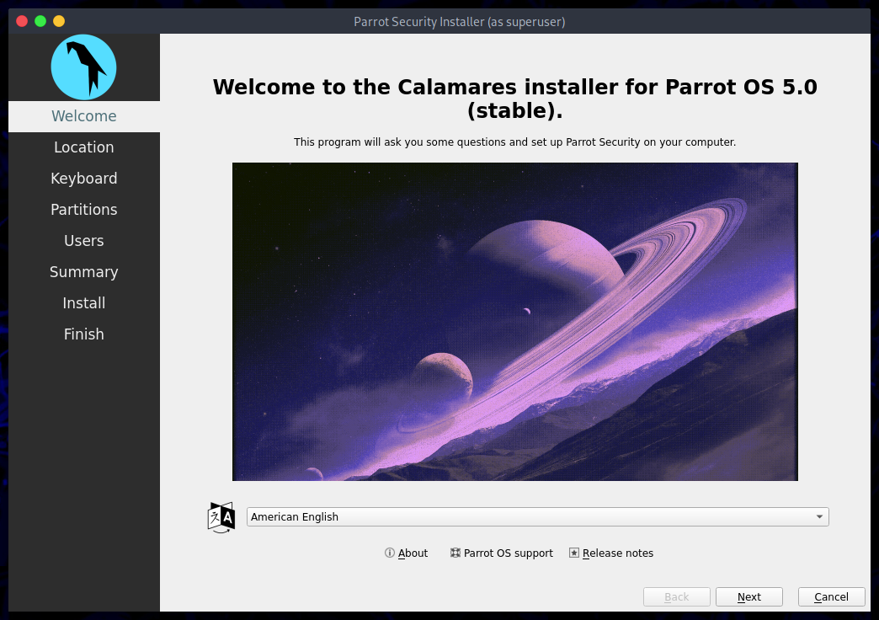

Then select your Region and Zone. Click on Next.

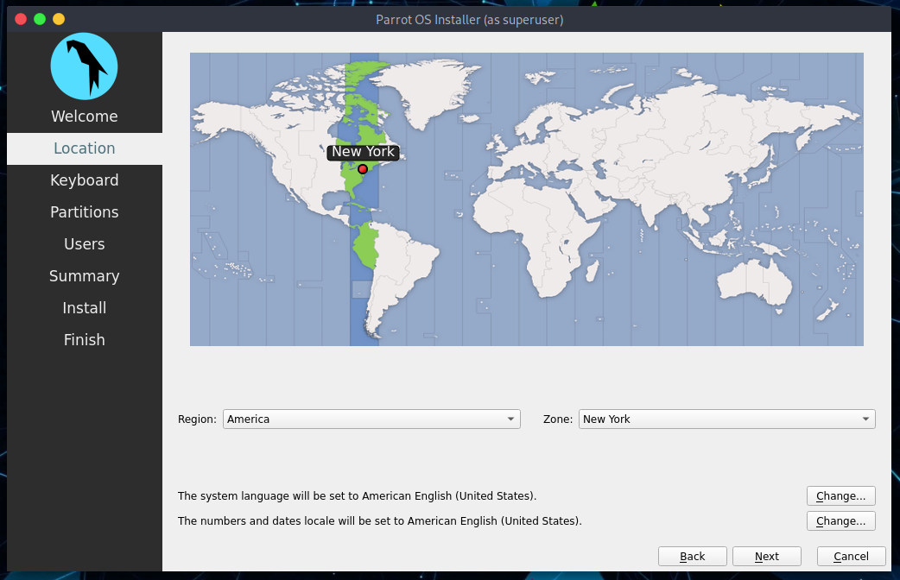

Now, you can select the keyboard layout. There are many variations available, and you can test them where its written "Type here to test your keyboard".

Click on Next.

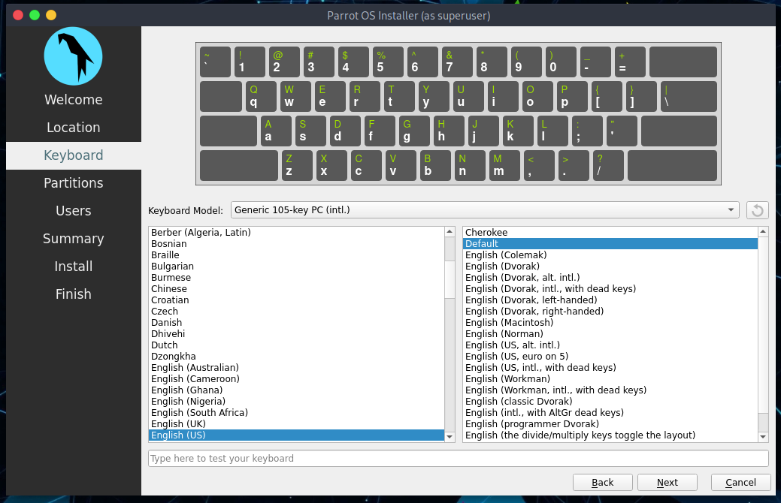

### Parrot Security disk partitioning[​](https://parrotsec.org/docs/installation/#parrot-security-disk-partitioning)

We think guided partitioning for less experienced users is recommended, 40 GB or more is enough, unless your going to want to install a lot of programs or keep larger file on your hard drive.

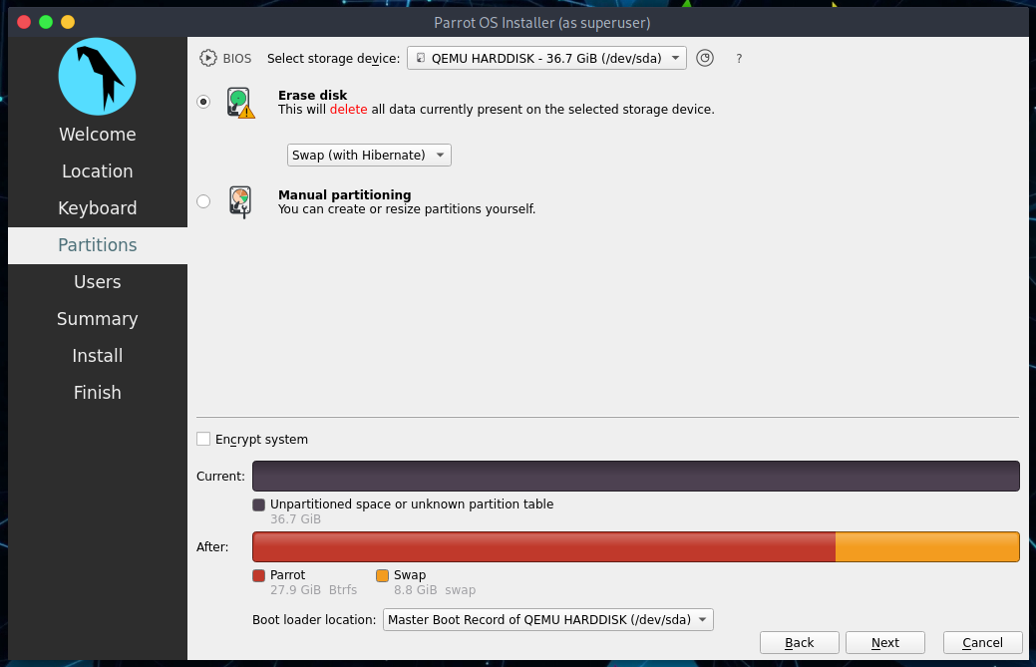

Here you can decide whether to enable swap or not. For more information about swap:

<https://wiki.debian.org/Swap>

<https://www.kernel.org/doc/html/latest/power/swsusp.html>

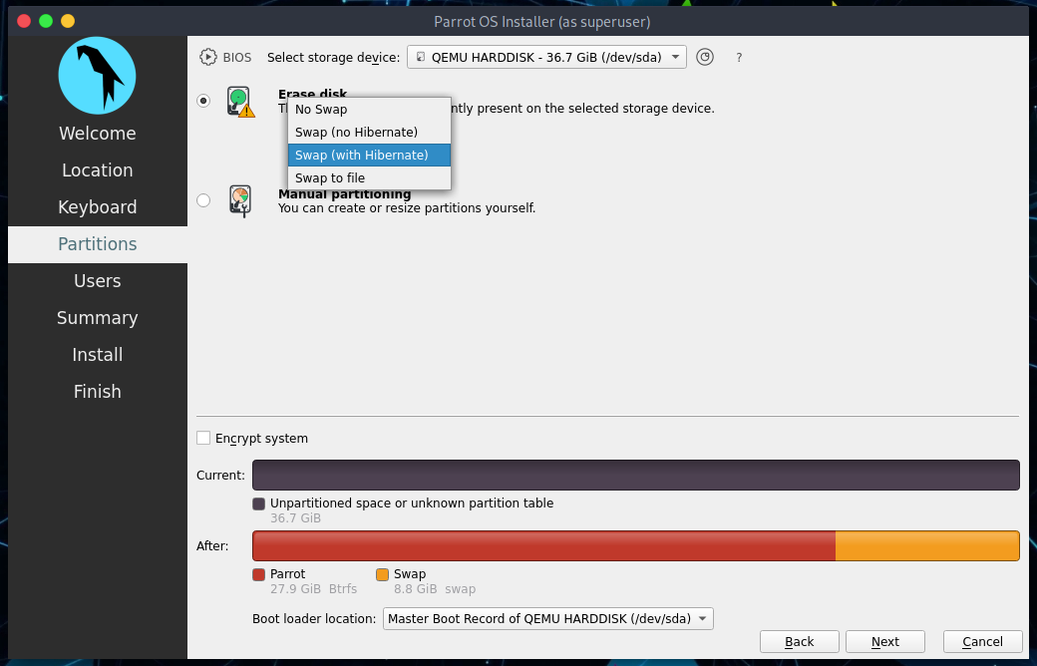

If you want, you can also encrypt the system by adding a passphrase:

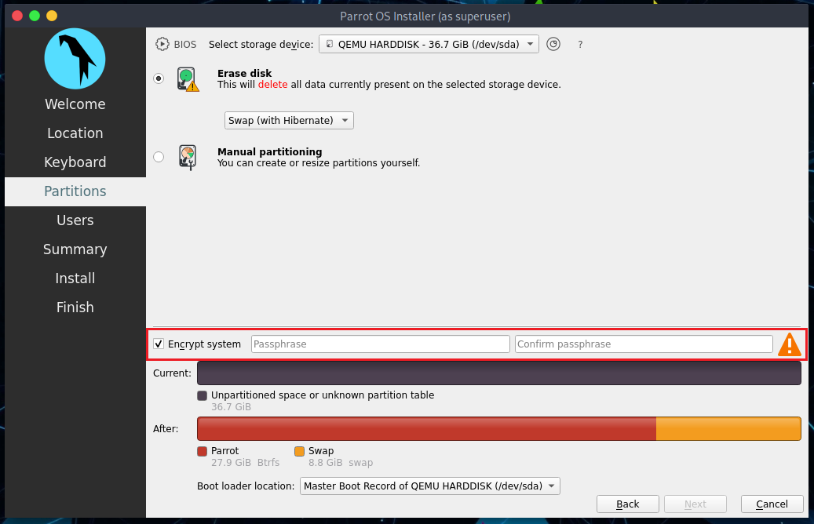

Select the options that you think will be most useful to you and click on Next.

### Creating a new user account[​](https://parrotsec.org/docs/installation/#creating-a-new-user-account)

You will be asked to create a new user, for simplicity we have chosen a **user**. You can enter any name in here.

Remember that it is the password to access your OS account, we recommend you to create a long and complex one.

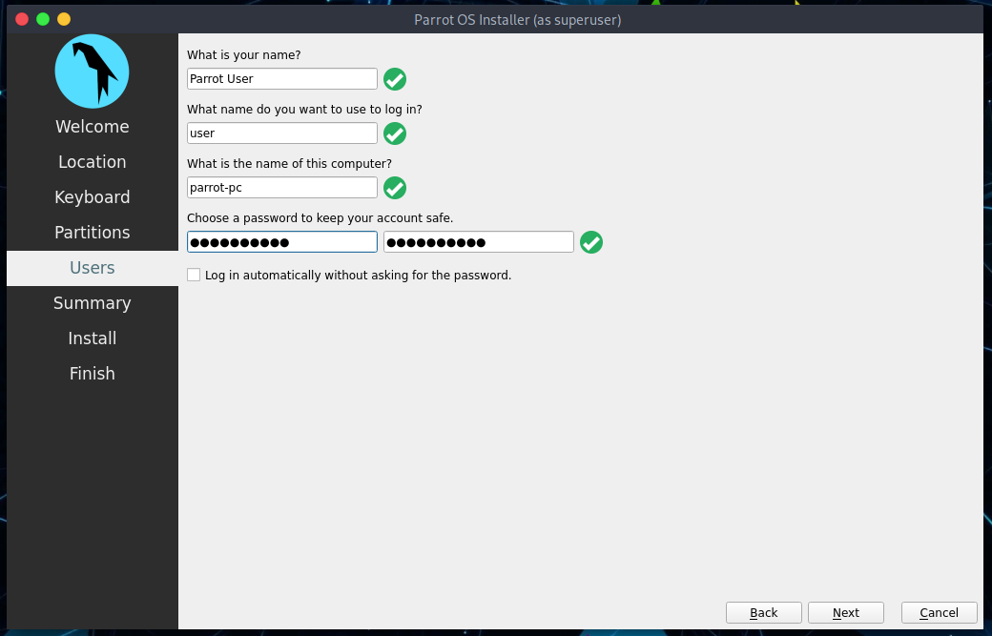

Then, click on Next.

### Completing the installation process[​](https://parrotsec.org/docs/installation/#completing-the-installation-process)

Finally, a summary of the choices made during the procedure:

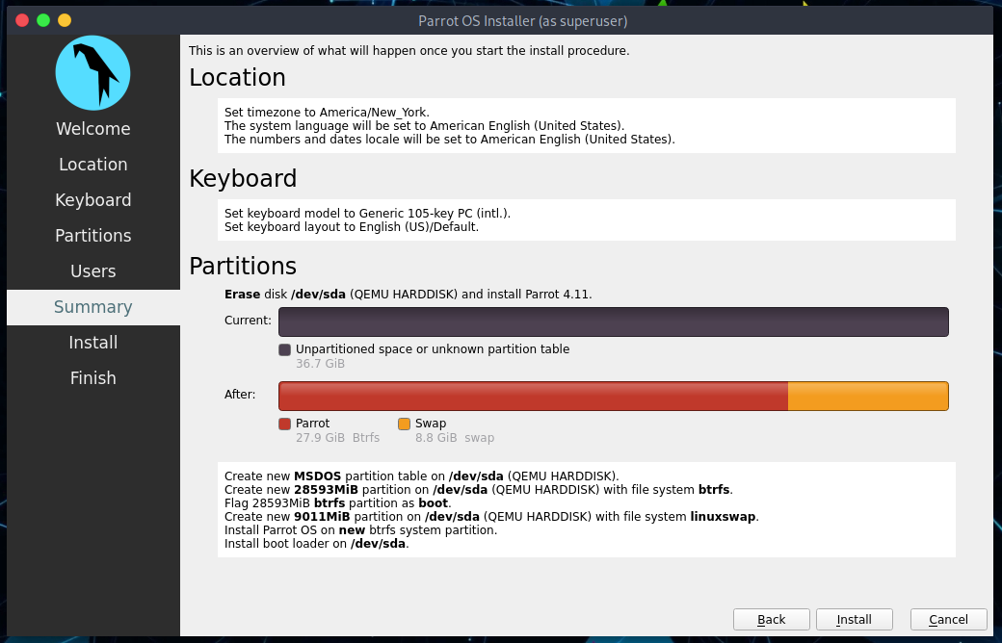

You can decide whether to change the chosen settings, and then go back, or proceed with the installation of the system. Click on **Install**.

Confirm by clicking **Install now**

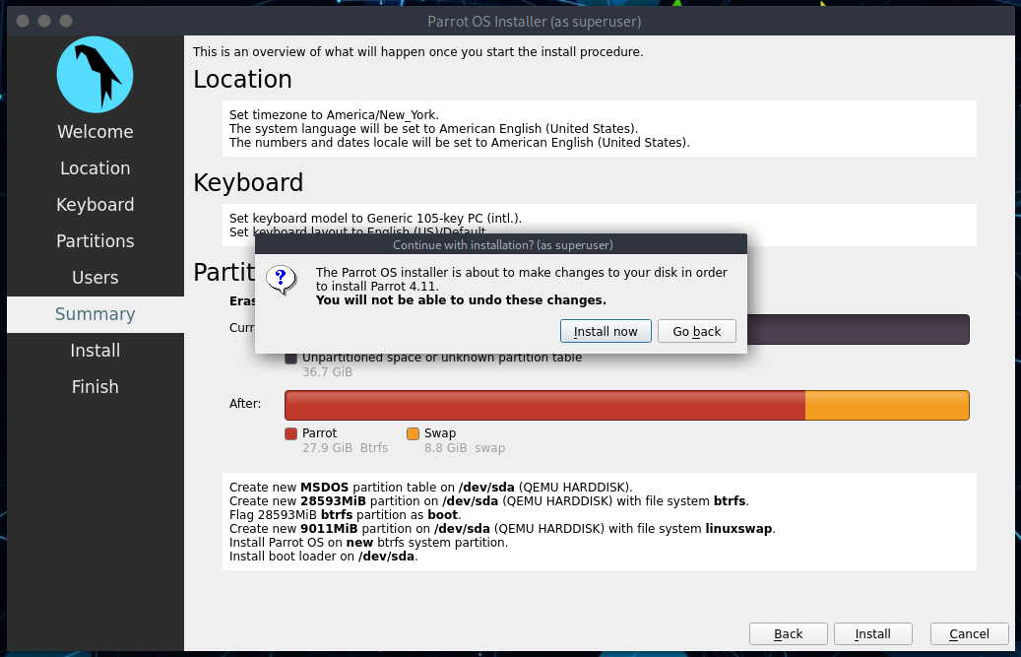

And wait for the installation to complete!

With an SSD (Sata), it will take a few minutes.

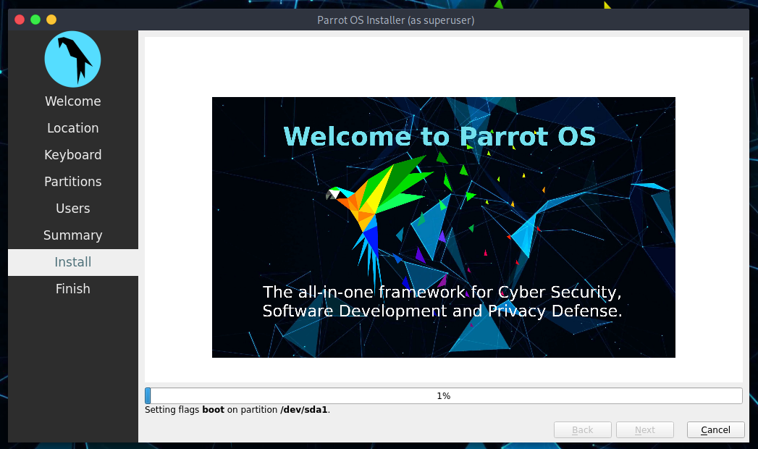

**Well done! You have successfully installed Parrot OS on your computer!**

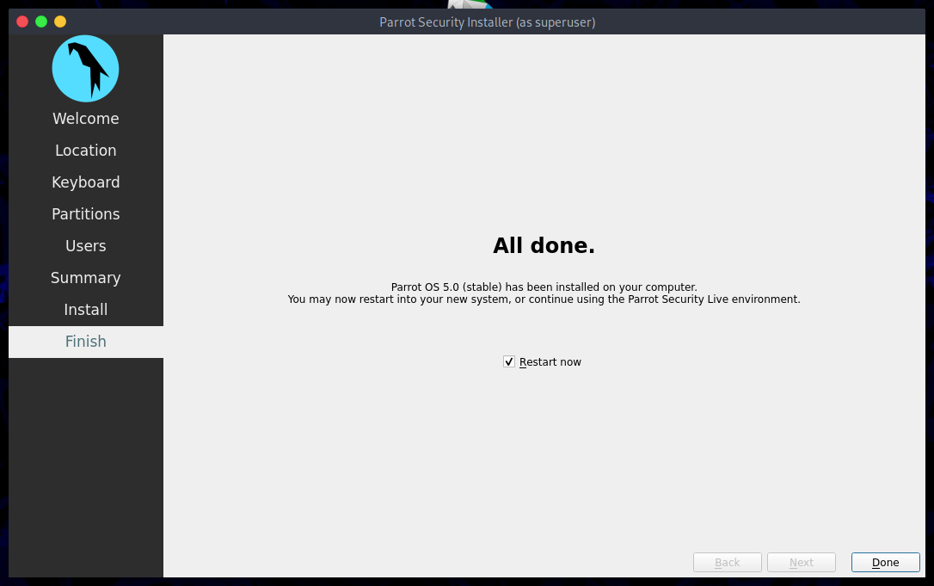

### Login to Parrot for the first time[​](https://parrotsec.org/docs/installation/#login-to-parrot-for-the-first-time)

Enter your Password:

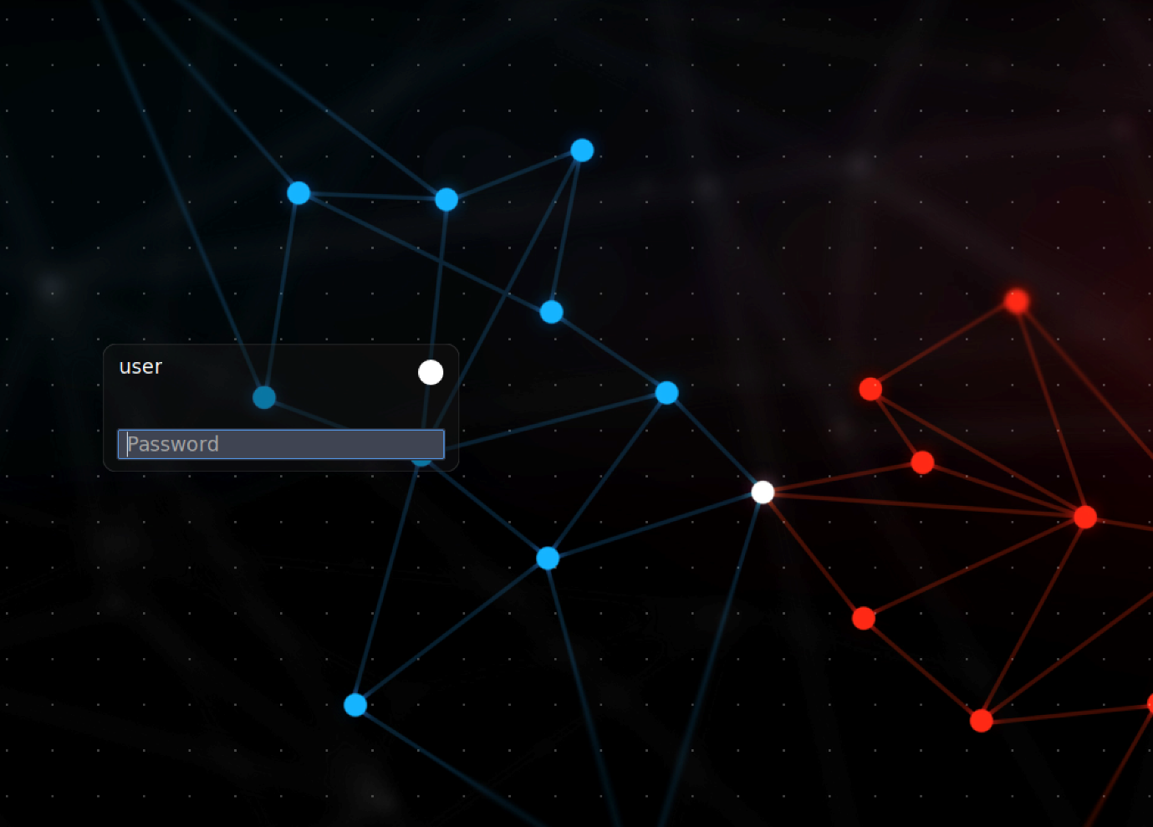

**Welcome to Parrot! Congrats!**

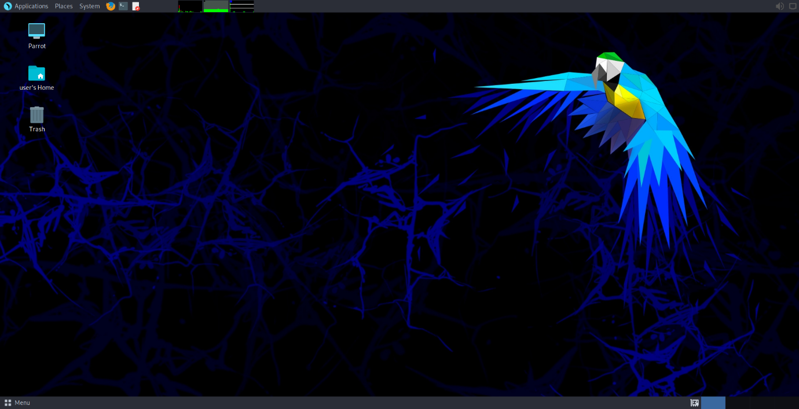

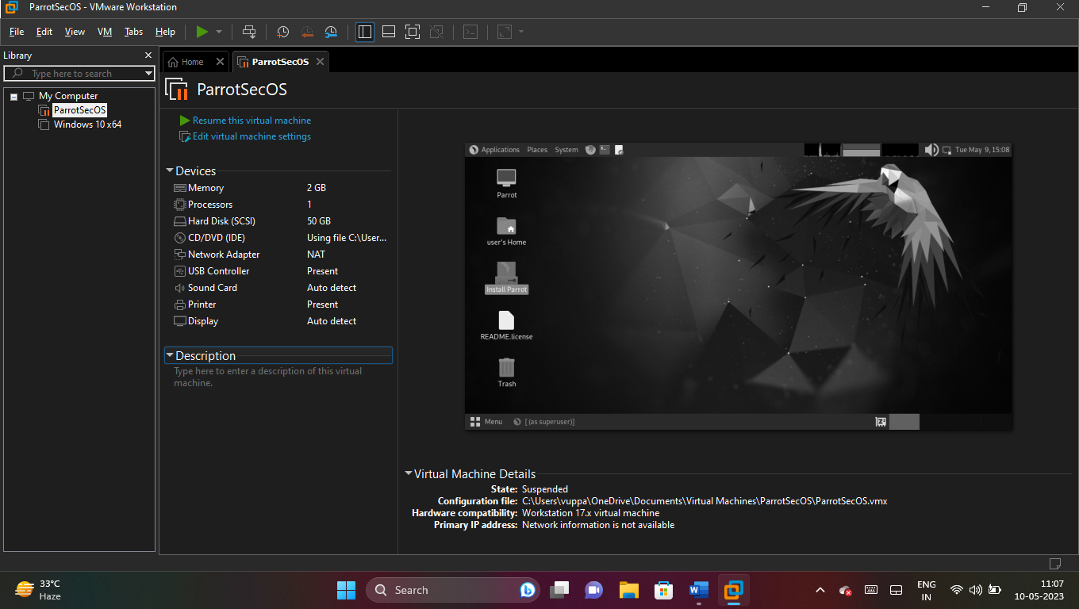

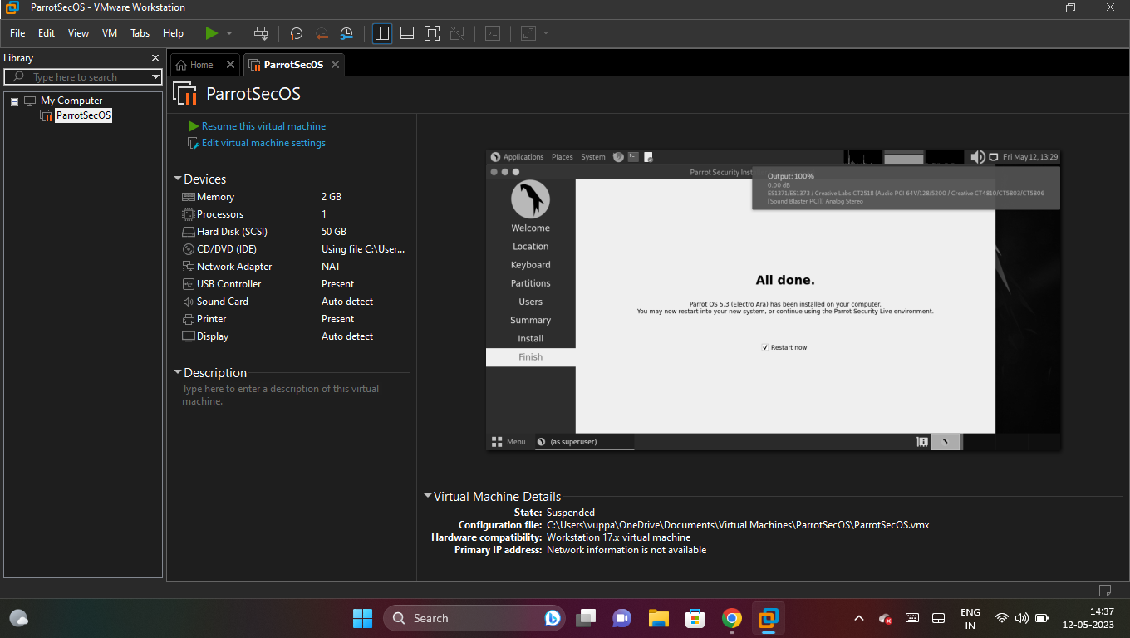

6.Download and install Windows 10/11

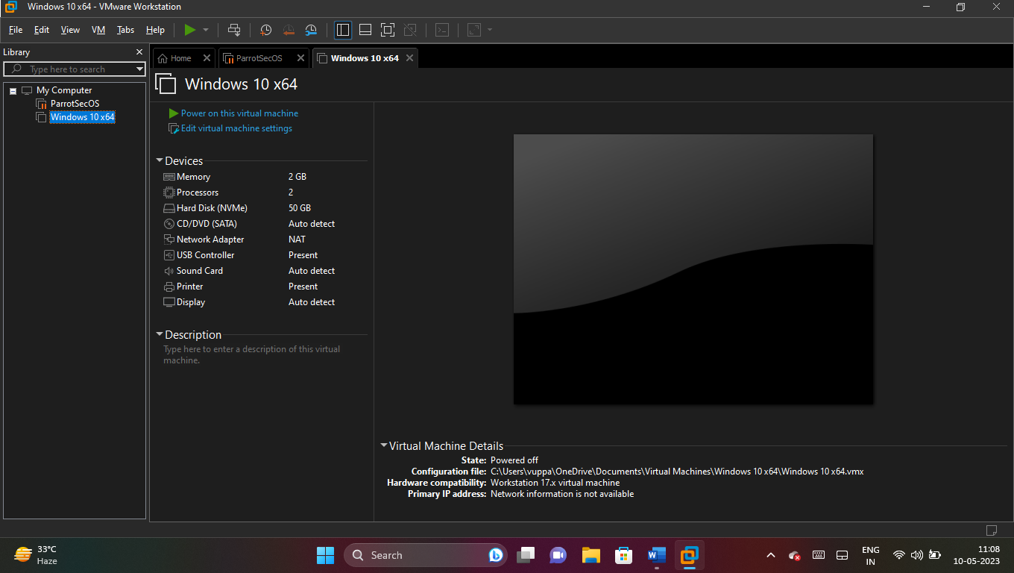

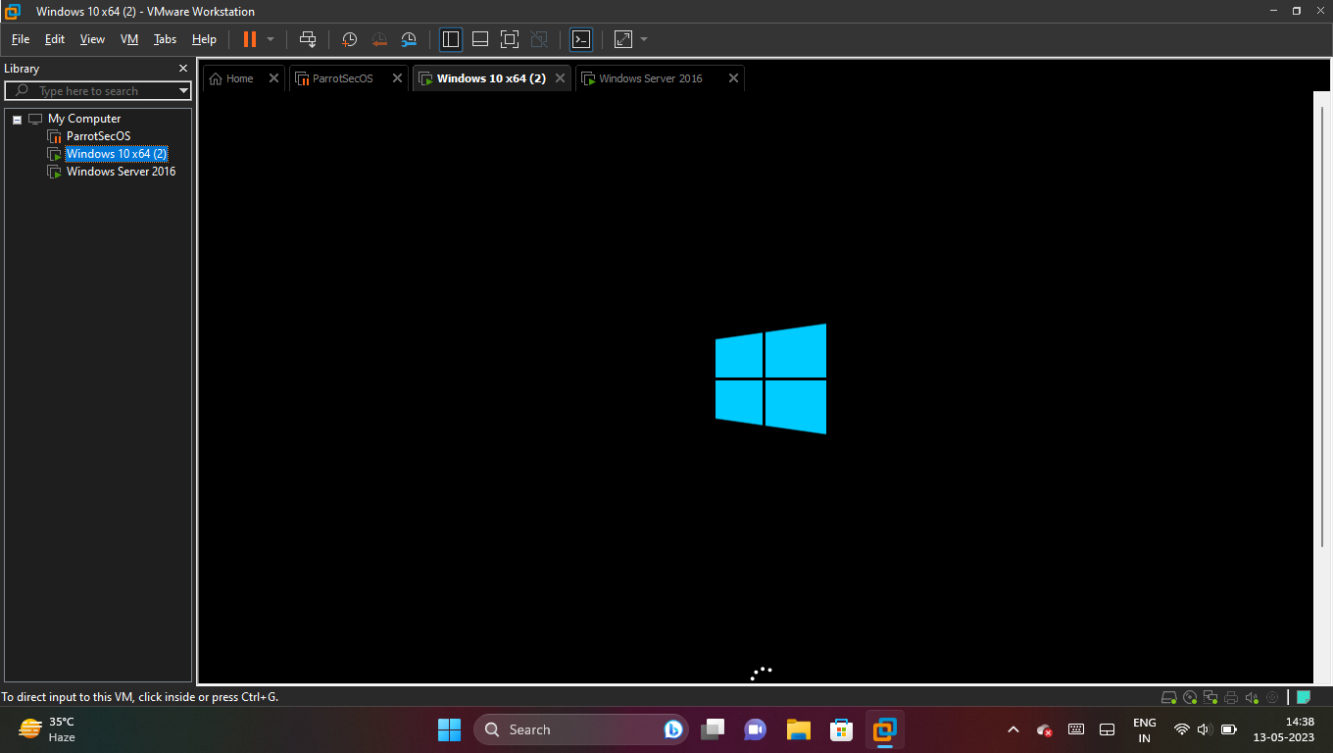

7. Download and install Windows Server 2016/2019/2022

